**How to achieve media integration in a changing situation? This book is worth reading**

Source: People's Forum Network

Editor: Wang Bo

2020-12-05

<https://www.rmlt.com.cn/2020/1205/600875.shtml>

At present, a new round of scientific and technological revolution and industrial transformation is reshaping the Internet industry ecology and media development pattern. General Secretary Xi Jinping pointed out that "promoting the development of media integration and building an all-media has become an urgent issue we face." In the context of a major change that has not been seen in a century, how can we do a good job in the development of media integration?

**The book "Great Changes - Mobile Empowers Value Communication"** written by Du Feijin and others and published by Commercial Press , centered on General Secretary Xi Jinping's important instructions on the in-depth integration of media, provides a comprehensive and thorough analysis of how mainstream media can use mobile communication to promote the in-depth development of media integration and seize the commanding heights of communication. People's Forum recommends reading.

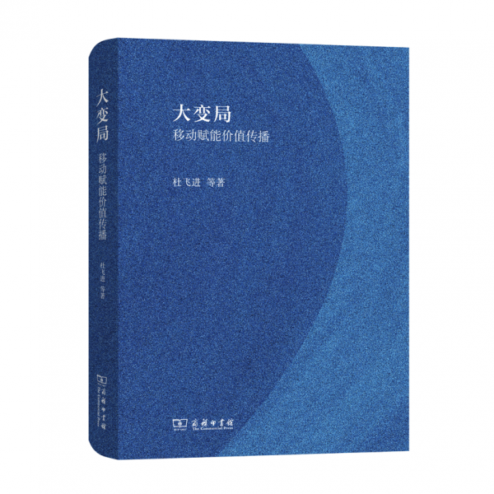

Source | People's Forum Magazine and [People's Forum Network](http://www.rmlt.com.cn/) (rmltwz)

Please indicate the source when reprinting

Media convergence is an important strategic deployment made by the CPC Central Committee with Comrade Xi Jinping as the core for propaganda and ideological work in the new era. It is an important part of promoting the modernization of national governance and has extremely important practical significance and far-reaching strategic significance. Since the development of media convergence was officially elevated to a national strategy in 2014, General Secretary Xi Jinping has repeatedly emphasized the importance and urgency of media convergence on many important occasions. In particular, in January 2019, when presiding over the 12th collective study of the Political Bureau of the CPC Central Committee, General Secretary Xi Jinping emphasized that "we must adhere to the mobile-first strategy and allow mainstream media to use mobile communication to firmly occupy the commanding heights of public opinion guidance, ideological leadership, cultural inheritance, and serving the people."

The world is in a major change that has not been seen in a century, which is a major issue that General Secretary Xi Jinping has repeatedly emphasized. Media convergence, based on the background of the great changes in the era, poses a very contemporary challenge to China's communication system under the great changes brought about by Internet technology. In the past six years, the practical exploration of media convergence has made certain progress nationwide. Starting from the People's Daily Central Kitchen, all provinces, cities and counties have basically built integrated media centers and explored some special experiences and innovative models. However, from the perspective of sustainable development, media convergence still faces many problems and challenges in terms of institutional mechanisms, operating models, content production, user management, and talent training. At the same time, the new era is an era of rapid change, with technological development advancing by leaps and bounds, and communication methods constantly being updated. Old problems are still there, and new problems are coming again. To continuously solve problems, we must not only accumulate practical experience, but also keep up with the pace of technological development and have continuous theoretical innovation with leadership and guidance.

The book "The Great Changes - Mobile Empowers Value Communication", written by Du Feijin and others and published by the Commercial Press in July 2020, is just such a book that keeps pace with the tide of the times and leads the new trend of mobile communication. The book closely follows the background of the times when my country has 900 million mobile users, and provides a comprehensive and thorough analysis of how mainstream media can use mobile communication to accelerate the development of media in-depth integration and seize the commanding heights of communication. It is both theoretical and practical. The characteristics of this book can be summarized in five aspects: high position, cutting-edge topics, rich content, in-depth thinking, and sharp views.

**Standing high**

This book is based on the great changes that have not been seen in the world for a century. It discusses media convergence in this context. From the perspective of a new era of mobile communication, it discusses the changes that have taken place in the world under mobile communication, as well as the new media ecology, new normal, and new business model that have arisen from it; it discusses the direction of my country's mainstream media under the above-mentioned "new three states"; and it discusses the issue of "how mobile can empower value communication". Through scientific analysis, this book systematically discusses the important instructions of General Secretary Xi Jinping on the deep integration and development of media from the perspective of theory and practice. It is a treatise with strategic height and innovative ideas.

**Topics**

As we all know, every leap forward in human communication is closely related to technological progress. The emergence of writing has made humans bid farewell to the oral communication stage, the emergence of the printing press has opened up the era of print communication, the emergence of electronic technology has brought humans into the era of electronic communication, and Internet technology has given birth to the era of network communication.

When media convergence was elevated to a national strategic level in 2014, researchers were still basing their thinking on the paradigm of the primary stage of online communication, and their research was mostly based on the basic theories of online communication. However, the book "The Great Changes: Mobile Empowers Value Communication" goes beyond the primary stage of online communication and directly points to the latest frontier of online communication: **mobile communication** . The book succinctly discusses the laws of mobile communication and enriches the theory of mobile communication, which is of great contemporary significance.

**Rich in content**

This book is like an encyclopedia of media convergence, with rich content. From the analysis of the concept of convergence, to the path and current situation of convergence, to the prospects and countermeasures, the author has carried out in-depth and detailed sorting, analysis and demonstration. Each of the thirteen chapters leads a major proposition, from the discussion of converged media strategy under mobility, to convergence means and business countermeasures, from technology to people, from content to channels, it covers everything, showing the media convergence strategy and its implementation led by the Party and the government, actively practiced by the media, and promoted by the whole people. In particular, relevant policy recommendations are put forward based on the evaluation model and prospect forecast, which has great practical significance and practical value.

**Thinking Deeper**

The book has conducted in-depth thinking on key issues. There are many hot words in the book, such as "changing lanes to overtake", "Chinese-style media integration", "communication content supply side", "multi-wheel drive", etc. Each word is the product of thinking. For example, the term "changing lanes to overtake" goes beyond the commonly used concept of "overtaking on a curve" in the past. It regards the breakthrough new opportunities brought by mobile communication technology to mainstream media in the process of deep media integration and development as a brand-new fast lane, and points out a new direction for traditional mainstream media to seize the Internet communication position. Whether or not to occupy the main position of mobile communication is a hard-core task for the in-depth development of media integration.

The book profoundly discusses the paths and methods of mobile-enabled value communication, analyzes the advantages and disadvantages of mainstream media, and proposes a series of important viewpoints such as updating communication concepts, developing new terminals, building a central kitchen, optimizing planning, gathering, editing and publishing, focusing on user connections, and cultivating all-media talents. It provides theoretical and methodological support for mainstream media to innovate systems and mechanisms, build new systems, seize mobile Internet communication positions, and achieve "overtaking in different lanes."

**Sharp views**

Many of the viewpoints in this book point directly to the pain points of media convergence. For example, the book points out that in the face of the surging new media, whether mainstream media can maintain their position in public opinion and how to seize the information high ground are all difficult "hurdles" in the development of convergence. Especially when discussing audience thinking and communication effects, this book points out the shortcomings, defects and difficulties of media convergence. For example, when the strong political connection between the media and users disappears and user loss is serious, how to rebuild user connections and attract users to their own banner again is a major challenge facing mainstream media.

Indeed, facing new media platforms such as Toutiao and Douyin, which have huge daily active users, how to attract and retain users is a difficult task. One of the important viewpoints of this book is that traditional media should not only establish user thinking, but also innovate profit models. In addition, this book also proposes to relax the political environment of mainstream media and create a good media ecology. These issues are bottlenecks in the integration process.

Media convergence is the only way to firmly grasp the initiative and dominance of public opinion in the era of all-media. Although there are many difficulties, in fact, the advantages of mainstream media are quite significant. During the epidemic, the New Media Research Institute of Peking University conducted a large-scale survey on the public's sources of information about the epidemic and found the top ten sources of information for the public to obtain epidemic information.

Survey data shows that the most used information source during the epidemic is instant messaging/social media represented by WeChat and Weibo, with 92% of the respondents using it as their main source of information. The highest satisfaction is also instant messaging/social media, ranking first with the highest average score of 3.7 points. However, the public still trusts official media the most. Radio and television news, government department websites, and community information and publicity agencies ranked first, second, and fourth in the credibility survey (average scores of 4.37, 4.36, and 4.09, respectively). From this point of view, although the public gathers in social apps for entertainment, when they really face major events and major decisions, they still expect official voices and trust mainstream media.

Obviously, the inherent advantages of mainstream media are unmatched by other media. As long as we understand and grasp the laws of mobile communication, let mainstream media seize the market and the high ground of public opinion guidance, and occupy the mobile communication position with mainstream values, it will definitely be achieved. Of course, it is also extremely difficult to implement. The programmatic framework given in this book still needs more examples to prove it.